Git Branching and Merging
Aim:
To create a new branch, make changes in the branch, merge it into the main branch, and delete the branch using Git.
Tools Required:
- Git Bash
- GitHub
- Windows PC
- Existing Git Repository (GitDemo)
Procedure:
- Open the existing Git repository.
- Create a new branch named GitNewBranch.
- Switch to the new branch.
- Create a new file (branch.txt) and add content.
- Stage and commit the file.
- Check the repository status.
- Switch back to the main branch.
- Compare the branch with the main branch.
- Merge GitNewBranch into main.
- View the commit history.
- Delete the merged branch.
- Push the updated repository to GitHub.
Commands Used
- cd ~/GitDemo
- git branch GitNewBranch
- git branch
- git checkout GitNewBranch
- echo "This file is created in GitNewBranch." > branch.txt
- git add branch.txt
- git commit -m "Added branch file"
- git status
- git checkout main
- git diff main GitNewBranch
- git merge GitNewBranch
- git log --oneline --graph --decorate
- git branch -d GitNewBranch
- git push

OUTPUT:
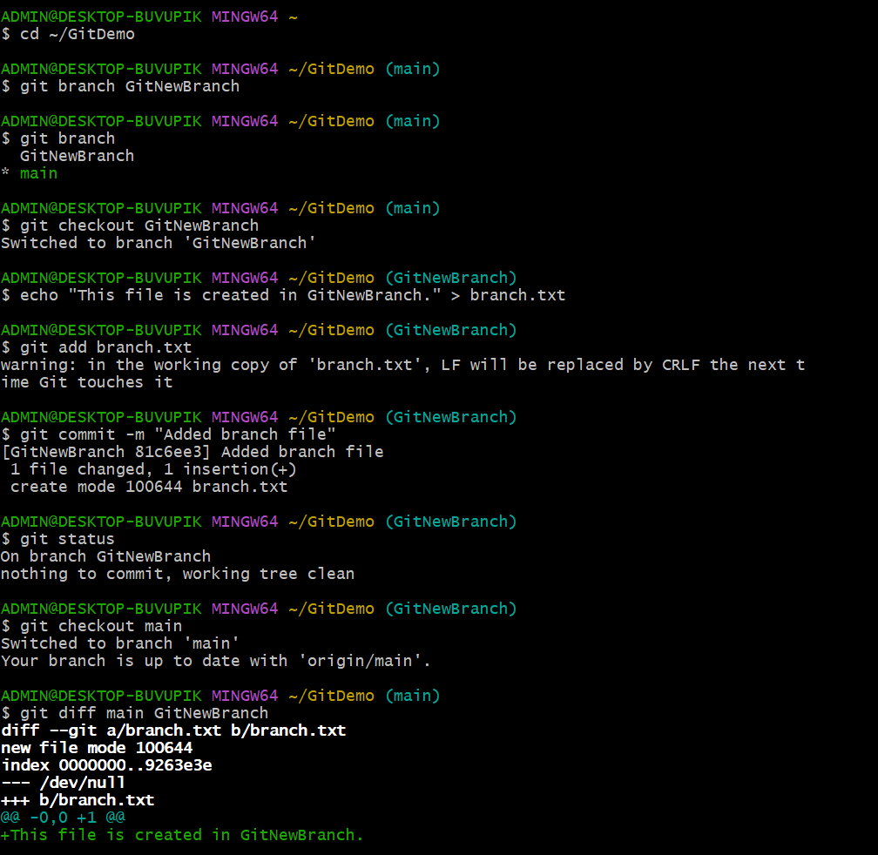

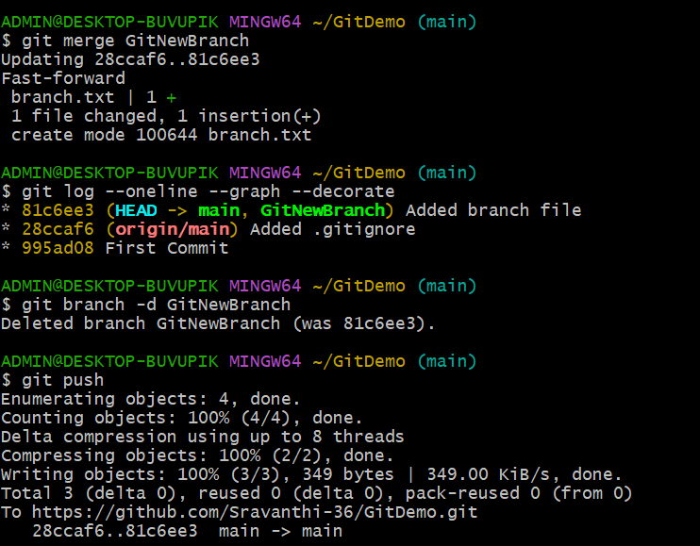
Successful commit of branch.txt

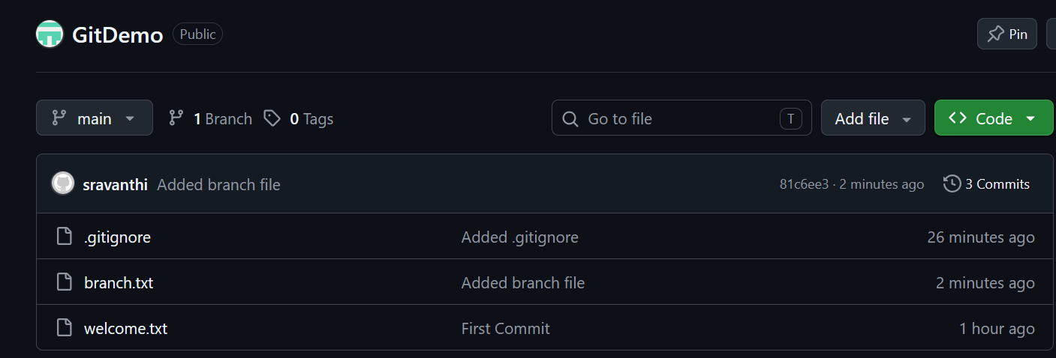

Result:

Successfully created a new branch, committed changes in the branch, merged it into the main branch, deleted the merged branch, and pushed the updated repository to GitHub.

